Assignment 7

1.Problem Statement

Implement Forward Chaining Algorithm
The goal of this assignment is to implement the Forward Chaining algorithm, which is used to infer new facts from a given set of known facts within a knowledge base. This technique is essential for rule-based systems where knowledge needs to be derived dynamically.

2. Objectives
- Understand the principles of rule-based reasoning.
- Implement the Forward Chaining algorithm for knowledge inference.

3. Theory

What is Forward Chaining?
Forward Chaining is a method of reasoning in which inference rules are applied to known facts to derive new facts. It works in a data-driven manner, continually adding new facts until no more can be inferred.

4. Methodology
- Start with an Initial Set of Known Facts:
  - Initialize your knowledge base with a set of known facts that can be used as starting points for inference.
- Apply Rules to Infer New Facts:
  - Each rule in the knowledge base typically has a premise (the condition) and a conclusion (the fact to be inferred). If the premises of a rule are satisfied by the known facts, then the conclusion of that rule can be added to the set of known facts.
- Repeat Until No More Facts Can Be Inferred:
  - Continue applying the rules iteratively, adding new facts to the knowledge base, until no additional inferences can be made.

4.Working Principle / Algorithm
Here’s a simple outline of the Forward Chaining algorithm:
- Initialize the Knowledge Base:
  - Represent known facts and inference rules. For example:
    - Facts: F1,F2,…,FnF_1, F_2, \ldots, F_nF1​,F2​,…,Fn​
    - Rules: If AAA and BBB, then CCC.
- Create a Loop for Inference:
  - While there are new facts that can be inferred:
    - For each rule in the knowledge base:
      - Check if the premises of the rule are satisfied by the known facts.
      - If satisfied, add the conclusion of the rule to the known facts.
- Output the Inferred Facts:
  - Once no more facts can be inferred, output the final set of known facts.

5.Advantages
- Dynamic Inference: Forward chaining is efficient for systems where new facts are added regularly, as it allows for continuous reasoning.
- Simplicity: The algorithm is straightforward to implement and easy to understand.

6. Disadvantages / Limitations
- Unnecessary Inferences: If not carefully managed, forward chaining can infer facts that are not required for the problem at hand, potentially leading to irrelevant conclusions.
- Computationally Intensive: For large knowledge bases, repeated rule applications can become computationally expensive.

7. Diagram

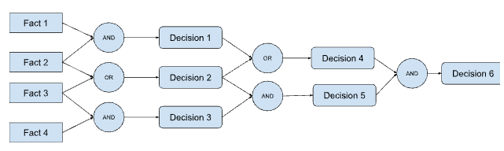

8. Conclusion
Forward chaining is an effective method for reasoning in rule-based systems, allowing systems to infer new knowledge dynamically. Its ability to generate conclusions from a set of premises makes it a powerful tool for applications in artificial intelligence and expert systems.

